LINKEDIN

AMIT PANDEY

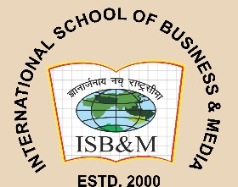INTERNATIONAL SCHOOL OF BUSINESS & MEDIA POST GRADUATE DIPLOMA IN MANAGEMENT MARKETING & BUSINESS ANALYTICS



Email: [amitpandeyup33@gmail.com](mailto:amitpandeyup33@gmail.com)|| Ph.: 7355393918 | PUNE

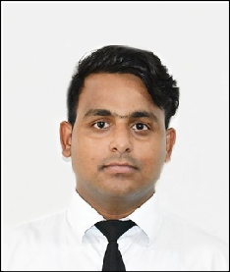

EXECUTIVE SUMMARY

Interested for an entry-level position in marketing where I can put my master's-level expertise in the field to use. exceptionally good at performing market research and developing brand awareness initiatives. Excellent communication skills are necessary to persuade new customers and clients.

# ASSIGNMENTS AND PROJECTS

* B2B marketing foundations
* Digital Marketers
* Enterprise Development Programs
* Rural agriculture work experience programs (RAWEP)

EDUCATION

PGDM (2022-24) – | Pursuing | B.SC Agriculture | 2018-2022| PERCENTAGE: 74.85

Rama University Kanpur Uttar Pradesh

SSC| 2015| PERCENTAGE: 71

M.L.M.L inter college Ayodhya HSC| 2017 |

PERCENTAGE:63

M.L.M.L inter collage Ayodhya

ACHIEVEMENTS

* Appreciation letter received from your graduation college.

SKILLS

* Microsoft Excel
* Problem-solving
* Leadership
* Project management

CERTIFICATES

* Analysis of the financials statement of HUL company.
* Analysis of the financials statement of PIDILITE industries.
* Completed the big basket case study.
* Completed the marketing funnel with the AIDA model and AIDAL.
* STP model by selecting product and service.
* 4 p’s in marketing.
* Visit [www.ninewest.com](http://www.ninewest.com/) and search the internet, including social media and your
* library’s online databases, to obtain information on the marketing strategy of NINE WEST.
* 7 C online marketing framework.
* SWOT analysis for Starbucks and Dunkin’s Donuts. Based on your analysis in which company would you invest.

# EXTRA-CURRICULAR ACTIVITIES

* I have been a cricket captain for 4year in my college and I like team management.
* Participating in school, college, or community sporting programs and events can be a full fill and enriching experience.
* I was a sports coordinator in my graduation period.
* It worked as a volunteer in national conference.
* One month complete my internship in online marketing.